—------------------------------------------------------------------

As a crucial cognitive function, working memory is important for information storage and processing to complete tasks. N-back trials is one of the most widely used tasks to measure and assess working memory efficiency (Meule, 2017). In this task, the participants are instructed to memorize a sequence of stimuli and indicate whether the current stimulus matches the one that appeared in the N steps back of the stimulus sequence. The frontal, cingulate, and parietal cortical regions are known to be activated during the N-back task, suggesting their involvement in working memory (Tsuchida et al., 2009, Chat et al. 2018). Regional activity is sensitive to memory load (Barch et al., 2013).

The human connectome project (HCP) was launched in 2010 and provides a robust dataset of task-evoked functional magnetic resonance imaging (tfMRI) (Barch et al., 2013). The dataset includes a working memory task with 2 N-back trials (0-back and 2-back).We hypothesize that the regional activity amplitude of the brain during the n-back task can indicate the load type.

Here we investigate regional brain activity in 2 different load types; 0-back and 2-back trials of four different visual stimuli: body, tools, faces, and places to predict load types during the N-back task using fMRI data collected by HCP. We split the data into a train group and a test group. We conducted logistic regression on the activity of regions of interest that are obtained from previous studies and our own results to construct a predictive model that can accurately forecast load types. Finally, we evaluated the predictive performance of our model. The findings of this study holds potential to extend the understanding of the neural correlates that underline appropriate performance of associated brain regions.

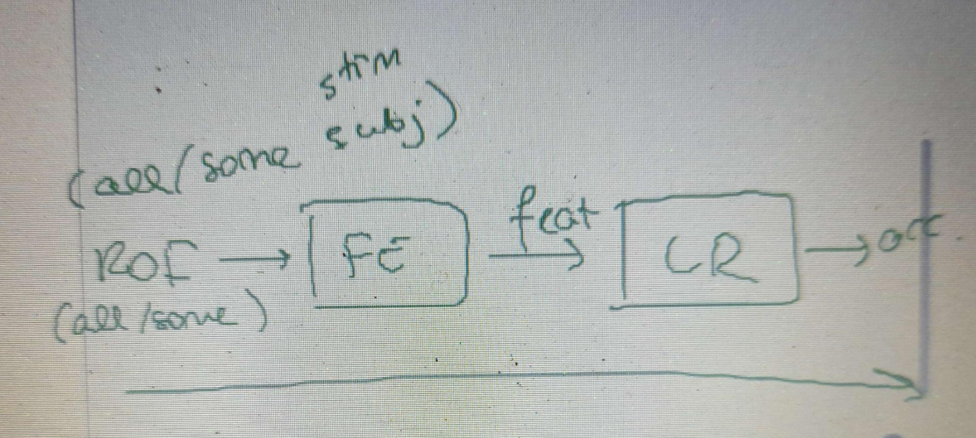

fMRI hand book: <https://www.cs.mtsu.edu/~xyang/fMRIHandBook.pdf>

Logistic regression: <https://scikit-learn.org/stable/modules/generated/sklearn.linear_model.LogisticRegression.html>

**A. What are the phenomena? Here summarize the part of the phenomena which your modeling addresses.**

As a crucial cognitive function, working memory is important for information storage and processing to complete tasks. N-back trials is one of the most widely used tasks to measure and assess working memory efficiency (Meule, 2017). In this task, the participants are instructed to memorize a sequence of stimuli and indicate whether the current stimulus matches the one that appeared in the N steps back of the stimulus sequence. Increase of memory load generally increases functional connectivity (reference needed). The frontal, cingulate, and parietal cortical regions are known to be activated during the N-back task, suggesting their involvement in working memory (Tsuchida et al., 2009, Chat et al. 2018).

The level of difficulty increases as the number of steps increases. Regional activity is sensitive to memory load (from preliminary data and HCP paper).

**B. What is the key scientific question?: Clearly articulate the question which your modeling tries to answer.**

Is it possible to predict/decode the type of memory load by the activity in ROIs?

**C. What was our hypothesis?: Explain the key relationships which we relied on to simulate the phenomena.**

Level of activity in the 24 mentioned ROIs will indicate the type of memory load based on logistic regression model.

**D. How did your modeling work? Give an overview of the model, its main components, and how the modeling works. ‘’Here we … ‘’**

Input: average / maximum activity in ROIs

Feature extraction

Logistic regression to find the best coefficients

Output: predicted memory load types

**E. What did you find? Did the modeling work? Explain the key outcomes of your modeling evaluation.**

It is expected that activity level was able to discriminate between 0-back working load and 2-back using a temporal summary of the activity in every 360 ROIs for 339 subjects as features to the classifier.

**F. What can you conclude? Conclude as much as you can *with reference to the hypothesis*, within the limits of the modeling.**

Activity in … regions can predict load types

**G. What are the limitations and future directions? What is left to be learned? Briefly argue the plausibility of the approach and/or what you think is essential that may have been left out.**

Future direction:

A general model for all types of stimuli; use functional connectivity; use correct trials only; predict correct / error trials

—------------------------------------

Abstract:

Working memory is our ability to hold information in mind for a short time; its capacity is

limited and it relies on activity in multiple brain regions. Working memory is essential for temporary memory storage and processing to efficiently complete cognitive tasks. In the N-back task, the complexity of the task increases as the number of steps increases. Regional brain activity is sensitive to memory loads . However, to what extent do the activities in different regions of interest reflect the load of working memory remains unclear. We hypothesize that the memory load type can be classified using a temporal summary of the activity level from regions of interest. Here we explore the feasibility of using a logistic regression model to predict the load type of the N-back task. We were provided with 339 subjects from the Нuman Connectome Project

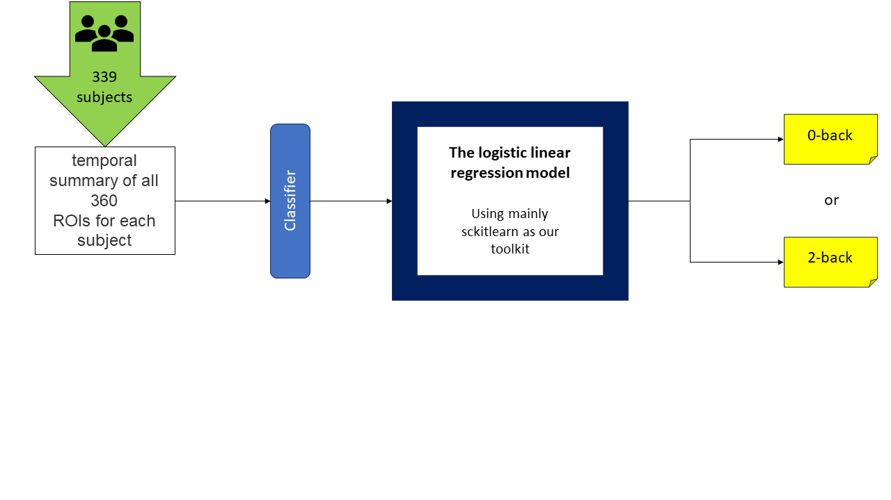

**Abstract drafts**

Mohamed:

Working memory is our ability to hold information in mind for a relatively short time; its capacity is limited and relies on activity in multiple brain regions. Working memory is essential for temporary memory storage and processing to efficiently complete cognitive tasks. In the N-back task, the complexity of the task increases as the number of steps increases. Regional brain activity is sensitive to memory loads. However, it remains unclear to what extent the activities in different regions of interest reflect the load of the working memory task. We hypothesize that the activity level in the mentioned regions of interest will indicate the type of memory load using a predictive model. Using the data provided from the HCP dataset of 339 subjects, we were able to develop a logistic regression model that can predict the memory load type based on a temporal summary of the activity of every 360 ROIs for all 339 subjects as features to the classifier. This study was able to show that activity in the mentioned regions were able to discriminate between 0-back and 2-back trials. It is suggested to furthermore investigate other different levels of memory load as well as screen for the specific regions that contribute the most to the model accuracy.

Polina:

Functional magnetic resonance imaging techniques enable us to estimate brain activation while performing tasks that require working memory. Working memory is a short-term memory function in the brain that processes verbal and perceptual data. This memory allows us to manipulate objects and numbers to perform complex tasks. Working memory is one of the three main executive functions that help people organize tasks, regulate emotions, and pay attention to the current moment.

The n-back task is a widely used measure to assess working memory function. It remains unclear how the activities in various regions of interest accurately represent the workload of working memory. The activity level was able to differentiate between low and high working loads by analyzing the temporal summary of activity in 360 regions of interest for 339 subjects using different stimuli. Considering brain activation at the correct 0- and 2-back we found certain brain regions were more active. By using the intensity of the fMRI signal it was possible to predict load type on each attempt. We use a logistic regression model to predict the type of N-back task load by identifying the brain regions of interest using previous studies and correlation analysis.

Elisee:  
Working memory plays a vital role in information storage and cognitive tasks. The N-back task is commonly used to assess working memory efficiency, where participants are required to memorize a sequence of stimuli and identify if the current stimulus matches the one that appeared N steps back. The activation of some brain regions during the N-back task indicates their involvement in working memory. Additionally, regional brain activity is sensitive to memory load.

This study investigates regional brain activity during two different load types (0-back and 2-back trials) for various visual stimuli, including body, tools, faces, and places. The aim is to decode the load types from functional magnetic resonance imaging (fMRI) data. Feature extraction is performed on the dataset, then it is divided into a train group and a test group, and logistic regression is conducted on regions of interest (ROIs) to construct a predictive model. The model's performance is then evaluated.

The hypothesis relies on the assumption that activity levels in the ROIs can indicate the type of exercise based on a logistic regression model. We will use the temporal summary of activity in 360 ROIs for 339 subjects as features for the classifier.

Mia:

Working memory is essential for temporary memory storage and processing to efficiently complete cognitive tasks. It has limited capacity and requires activities from multiple brain regions. Regional brain activity sensitively responds to memory loads in the N-back task when the complexity of the task increases. However, to what extent do the activities in different regions of interest reflect the load of working memory remains unclear. We hypothesize that the memory load type can be classified by using a temporal summary of the activity level from regions of interest. Here we explore the feasibility of using a logistic regression model to predict the load type of the N-back task. tfMRI (task-evoked fMRI) data of 0-back and 2-back tasks among 339 health subjects from the Human Connectome Project were used for modeling. The visual stimulation types in the task include body, faces, places, and tools. The activity in the regions of interest were averaged in all time series within test groups. Regions of interest were extracted as features for classification. A logistic regression model was constructed to explore the correlation between the features and the load type. Finally, we evaluated the model by measuring the predictive accuracy. The logistic regression model exhibits sufficient accuracy to predict the load type in the N-back task. The findings of this study hold potential to extend the understanding of the neural correlates that underline appropriate performance of associated brain regions. As for a future direction, this study potentially provides insights to develop predictive models of more conditions related to working memory.

Lexi:

Working memory (WM) is our ability to hold information in mind for a short time; its capacity is limited and it relies on activity in multiple brain regions. As a limited capacity system, it is sensitive to variations in the load we place on it (e.g. how many items we try to hold in memory at the same time). The N-back task, a commonly used experimental paradigm to study WM, allows us to vary the load by asking a participant to remember an item shown one or several trials previously and compare it to an item presented on the current trial. Previous research has shown that increases in load are linked with increases in connectivity between different brain regions. However, it remains unclear whether activity in specific brain regions can reveal information about WM load. We aimed to predict WM load from the activity in different regions of interest during 0-back and 2-back trials using fMRI data from 339 participants from the Human Connectome Project. We hypothesized that activity in (fronto-parietal?) regions would predict load type on each trial with above chance accuracy. Based on the results we obtain, we will determine whether WM load can be localized to specific cortical regions or it is likely to rely on a distributed system. Our conclusions are limited by our task design as the observed WM-related brain activity may vary depending on the task. Additionally, we have access to only two conditions (0-back vs. 2-back) with relatively small load and it may be possible that we need higher loads (e.g. 3-back+) to be able to accurately predict load on each trial from neural data. Understanding how activity in specific brain regions is linked to WM load may inform interventions targeting WM deficits which are common in patients diagnosed with psychiatric disorders, stroke and other conditions.

**Combined abstract:**

Working memory (WM) is our ability to hold information in mind for a short time; its capacity is limited, and it relies on activity in multiple brain regions. As a limited capacity system, it is sensitive to variations in the load we place on it (e.g. how many items we try to hold in memory at the same time). The N-back task, a commonly used experimental paradigm to study WM, allows us to vary the load by asking a participant to remember an item shown one or several trials previously and compare it to an item presented on the current trial. Previous research has shown that increases in load are linked with increases in connectivity between different brain regions. However, it remains unclear whether activity in specific brain regions can reveal information about WM load. Here, we explore the feasibility of using a logistic regression model to predict the load type of the N-back task using the activity level from 360 brain regions. Task-evoked fMRI (tfMRI) data of 0-back and 2-back tasks among 339 health subjects from the Human Connectome Project was used for modeling. Four types of visual stimuli were used: faces, places, tools, and body. A logistic regression model was constructed to predict the task (i.e. 0-back vs. 2-back) using the 360 regions of interest as input features. We also tested the effect of regularization and selection of a subset of brain regions to evaluate the model performance. The findings of this study hold potential to extend the understanding of the neural correlates that underline appropriate performance of associated brain regions. As for a future direction, this study potentially provides insights to develop predictive models of more conditions related to working memory.

—-

Working memory (WM) is an essential cognitive function to temporarily store and process the information which relies on activities from multiple brain regions. WM is sensitive to the memory load due to its limited capacity. One of the most commonly used experimental paradigms to assess WM using different memory load types is the N-back task. Previous studies have suggested that increases in load are generally associated with increases in functional connectivity between different brain regions. However, whether it is possible to reveal the WM load by using signals from brain regions has not been sufficiently investigated. In this study, we investigate the possibility of using a logistic regression model to classify the load type of the N-back task based on the activity level derived from 360 brain regions. To build the model, task-evoked fMRI (tfMRI) data from 339 healthy subjects who performed 0-back and 2-back tasks with 4 different visual stimulus types (places, faces, body and tools) sourced from the Human Connectome Project were utilized. The logistic regression model takes the activity in 360 brain regions of interest as the input for predicting the loading type (0-back vs 2-back). Furthermore, the regions of interest found to be contributing to well-prediction of the logistic regression model under regularization and those who are stated to be contributing to WM in the literature are compared. This study may help future models to make better predictions of working memory and reveal new features that could be associated with it.

—

After grammarly:

Working memory (WM) is an essential cognitive function to temporarily store and process information which relies on activities from multiple brain regions. WM is sensitive to memory load due to its limited capacity. One of the most commonly used experimental paradigms to assess WM using different memory load types is the N-back task. Previous studies have suggested that increases in load are generally associated with increases in functional connectivity between different brain regions. However, whether it is possible to reveal the WM load by using signals from brain regions has not been sufficiently investigated. In this study, we investigate the possibility of using a logistic regression model to classify the load type of the N-back task based on the activity level derived from 360 brain regions. To build the model, task-evoked fMRI (tfMRI) data from 339 healthy subjects who performed 0-back and 2-back tasks with four different visual stimulus types (places, faces, body and tools) sourced from the Human Connectome Project were utilized. The logistic regression model takes the activity in 360 brain regions of interest as the input for predicting the loading type (0-back vs 2-back). We also tested the effect of regularization and selection of a subset of brain regions to evaluate the model performance. This study may help with constructing future models to make better predictions of working memory and reveal new features that could be associated with it.